https://www.youtube.com/watch?v=cjURdvzty4c (video)
Gradual Release of Responsibility Youtube Outline
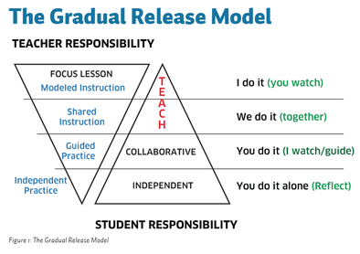

Outline of Video:

- You can do these components in any order however, all components should be present in every lesson every day for learning to occur.

Focused Instruction: (Teacher Does)
- Purpose
- An objective that is interesting or relevant to the students

- Teacher Modeling - Opening up your brain and modeling your thinking
- How you read, how you problem solve, think about a process etc...
2 Components:
* “I” statements
* Metacognition (Thinking about our thinking) We should use the words
“because, why or how”
*** Students need to hear expert thinking from their teachers

Guided Instruction: (Teacher & Student - We do it together)
Definition: The strategic use of questions, prompts and cues.
- Don’t tell the students the information they are missing
- When we question, prompt and cue, the students are doing the cognitive work.

2 Ways to do Guided Instruction:
- Rotate around small groups and insert yourself into the group
- Pull students from groups to form a group to do instruction with you - extention, remediation, etc...
*** Everyday teachers should be working the errors & misconceptions that
students have and don’t tell them - but question, prompt & cue them

Collaborative Learning: (Students Do - You do it, I watch & guide)
- Student-to-student interaction - They talk to each other.
- They interact in academic ways and use academic language
- Students need to produce the language to be able to learn the language
- Speak the discipline of science, math, history, art, social studies etc… to each other
- We need more time in school spent on collaborative learning

*** Something to think about - Why don’t teacher’s use collaborative learning?
- Principals want quiet classrooms
- Teacher’s own bad experience with group work when they went to school - usually one student does all the work
- Need to build individual accountability

Independent Learning: (You do it alone - reflect)
- Application of what we’ve been teaching students
- In-class independent learning and out-of-class independent learning (homework)
- We give homework prematurely in the instructional cycle

This link has lesson templates to help guide you in planning (Content Areas)
http://teacher.depaul.edu/Documents/GuidetoPlanningLessonswithGradualReleaseofResponsibility.pdf

This link shows what the teacher and student does in each component (Handout)
http://www.sjboces.org/doc/Gifted/GradualReleaseResponsibilityJan08.pdf

Videos of classroom teachers using gradual release of responsibility
https://www.teachingchannel.org/videos/improving-teacher-practice (literature)
https://www.youtube.com/watch?v=gleNo8dqHb8 (Social Studies lesson)
https://www.youtube.com/watch?v=uE_KTMRwbJs (writing lesson)
https://www.youtube.com/watch?v=3mZ9nqYvU1k&index=6&list=PL4rxPG74g3XciKSOjUguYtpy3ownIr6xv (Author’s Inference lesson)

