Creating a Supportive Literacy Environment
Relationships and Ownership
In effective learning partnerships, teachers build strong rapport with students as individuals and as a whole class creating a positive, trusting atmosphere. Knowing who students are as individuals and what matters most to them allows teachers to provide meaningful learning opportunities. Likewise, teachers need to share their lives in order to connect with their students and create an atmosphere in which individuals are valued, so that they feel safe and able to take risks.

“Once rapport has been established, teachers can begin building an alliance with the student: explicitly identifying a clear, meaningful goal or learning target and making a pact to work together in the service of improving a skill or conceptual understanding. Students will only commit to this work when trust has been built and when they are supported to develop a “growth mindset.” This means that students can see that growth is possible, and they understand that it requires consistent effort and a willingness to learn from mistakes.

Positive rapport and a strong alliance allow the teacher to gain cognitive insight, an understanding of how a particular student is learning. The teacher is able to understand specifically what and how the student is thinking as he or she works toward the learning goal. The teacher uses this information to help the student correct misconceptions and use new learning strategies effectively to self-correct and learn more independently. This creates the conditions for the student to begin to accelerate her or his own learning.” (National Equity Project 2010)

A supportive learning community allows for plenty of student choice and voice. Students need opportunities to self-select in order to promote a love of learning and inquiry while encouraging them to become independent thinkers and learners. In this kind of classroom community, children take an active role in planning and evaluating their learning. They are not passive recipients.

Structures
One tried and true method of incrementally transferring responsibility from teacher to student as literacy skills and strategies are taught is called the “gradual release of responsibility” model and has been given much emphasis by researchers and staff development experts. Initially, this includes direct and explicit instruction for students with some sort of demonstration/modeling of lessons in which the students observe the teacher with a specific purpose in mind. The next step of this model includes a shared experience in which the teacher provides a literacy lesson (reads a book, writes or edits a text, etc.) and the students help. This is then followed by an opportunity for students to try the newly demonstrated learning in a guided practice situation where the students assume responsibility to try the new skill while the teacher is prepared to readily assist. Finally, when teachers gradually release responsibility they encourage students to take ownership of their learning process during the independent practice phase. The ultimate goal is for the student to independently practice the skills and strategies, to self-monitor, and to apply this learning as the teacher observes.

The gradual release model can be used across a series of lessons and also across the year as students become increasingly proficient in taking on new processes and skills to assist them in becoming more effective readers, writers, and communicators.

Doug Fisher and Nancy Frey have recently revisited the gradual release model in their work with the Common Core. The chart below captures their view.

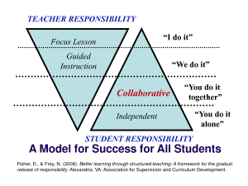

While Fisher and Frey maintain that there should always be a give and take between teacher and student responsibility they do not necessarily see this as a linear process. In other words at times a lesson may start with the teacher explaining a task and then students immediately trying to address the task independently before any kind of supports are put in place. They call this distributive scaffolding which is used only when necessary and is conducive to inquiry based models. In addition, it places value on “productive struggle” which builds stamina and encourages problem solving both emphasized as college and career readiness attributes in the Common Core.

Time: Literacy Blocks (suggested)
In learning to read, write, and communicate effectively students need time to practice and build stamina. Spending time reading contributes to the development of confident, accurate, and fluent readers as well as strength in comprehension. Spending time writing contributes to students writing fluency and confidence while allowing them to try out new writing forms and ideas. Classrooms need to be structured so that children are given access to large blocks of time to read, write, speak and listen. This also allows teachers time to assess needs, differentiate support, and give timely, specific feedback in order to accelerate learning.

When crafting a comprehensive literacy block teachers need to consider a balance of instructional designs over a week rather than just a day as was encouraged in the past. With time taken out for math (1.5 hours), another 30-40 minutes for PE/Music and an hour or so for lunch and recess that should leave approximately 2.5-3 hours for either an integrated or separate literacy and content (social studies/science) block. The elements of the balanced literacy model (see next section) become a menu to create the framework for instruction. Again, the goal is to have a balance of elements across the week.

The following sample schedules show how a teacher might design a week of instruction. These samples can be recursive (i.e., every Monday and Tuesday students will have a “close reading” experience or writer’s workshop the first 45-minutes of each day) or might change each week depending on the specific lessons involved.

Pink= Reading, listening and speaking experience
Blue= Writing
Yellow= Integrated Social Studies or Science content
ELA CCSS and Social Studies standards are embedded throughout the block

Monday | Tuesday | Wednesday | Thursday | Friday
Interactive Read Aloud of a biography (picture book) centered around the social studies theme (1st half of book) Includes time for “stop and jots” and in-depth discussion about the book content  (40 minutes) | Interactive Read Aloud of a biography centered around the social studies theme (2nd half of picture book) Includes time for in-depth discussion and writing response capturing our new learning about the Soc. Stud. theme/book content (60 min.) | Revisiting the text-  A Close Reading of SS text - 2 pages- each student has their own photo copy with space for annotations  Teacher models process- to read closely in order to identify details and examples explicitly when discussing what the text says and inferences drawn. (15 minutes) | Revisiting the text-  Teacher models rereading to glean more, taking the information from yesterday and adding to it. (SS text)  (10 minutes) | Students review what they have learned so far using quotes from the text and video in small groups. When done they can read or write independently  Teacher meets with group B  (40 minutes)
Independent reading +  3 short strategy groups  (30 minutes) | Independent reading + 1:1 conferring  (30 minutes) | In partners students practice the Close Reading and annotating strategy using photocopied pages. Share out.  (30 minutes). | Students participate in a chalk talk and then discussion about the text and their thinking.  (30 minutes) | Students are informed of their lit. study groups and convene to plan out their study given guiding questions. (20 min)
Vocabulary lesson tied to book and SS unit content  (10 min) | Word study mini lesson – words pulled from interactive read aloud (10 min.) | Independent Reading + Guided Reading (Group A) + 1:1 Conferring  (45 minutes) | Word study mini-lesson (10 minutes) | Independent Reading- +  Guided Group C+  Reading Assessment w/2 students (45 min)
Independent reading +  1 Guided reading group A +  1:1 reading conferring  (20 min) | Homogeneous  Word study groups  (20 min) Teacher works with 1 group | Adding to our knowledge about SS Theme- Watch a short video about the time period. Students collect information and take notes during the video.  (15 minutes) | Teacher introduces literature circle books tied to SS Theme. Students are asked to write to the teacher about their choices during independent reading time.  (10 minutes) | Writing Lesson- Starting your autobiog. – “hooking the reader”  Using Mentor texts as models  ( 30 minutes)
Writing lesson– immersion and discovery- exploring a genre- biographies & autobiographies- Compare and contrast  (30 min.) | 2nd Independent Reading +  1 Guided Reading Group (Group A)  (15 Minutes) | Discussion Groups:  Given a guiding question, students discuss the video comparing it to the biography they have been reading. (30 min.) | Independent reading +  2 Guided groups-  (Group B, Group C)  + 1 strategy group + 1:1 Conferring  (45 minutes) | Independent Writing + 1:1 Conferring in both Reading and Writing  (30 minutes)
Independent writing  + 1 Guided reading group (Group B) +  1:1 writing conferring  (30 min.) | Writing Mini-lesson-Authors choice-Structures of biog./autobiog.  (15 min.) | Writing lesson- Model  Structuring your autobiog.- sketching it out.  (20 minutes) | Writing minilesson- teacher shares some examples of sketched out autobios.  (15 minutes) | Sharing what we learned about ourselves as readers and writers this week  (15 min)
Sharing what we learned about ourselves as readers and writers  (20 min) | Independent writing + Guided Writing Group  Close with partner sharing  (30 min.) | Independent prewriting as students consider the structure they want to use.1:1 Writing Conferring/ Share  (25 minutes) | Independent writing- Students continue their prewrites- (free write if done) +  1:1 Writing Conferring  (30 minutes)
Vocabulary game
(30 minutes)

ELA CCSS and Science standards are embedded throughout the block
Monday |  | Tuesday |  | Wednesday | Thursday |  | Friday
First 60 minutes of literacy block M-Th. delegated to writers workshop (opportunities to read, speak /listen, and explore content are embedded)
Writing mini-lesson- Authors use different lengths of sentences to make their informational writing more interesting. Use Science Mentor text to show examples.  (15 minutes) | Writing mini-lesson- Teaching point: Adding adjectives to nouns can paint a vivid picture in the readers mind. Use a  Informational Read aloud to show  descriptive language –in particular adjectives and varying sentence lengths (20 minutes) |  | Interactive Writing  Given a short paragraph teacher and students collaboratively add details (adjectives) to some sentences about science topic.  (15 minutes) |  |  | Writing mini-lesson- Grammar lesson/ interactive editing  (10 minutes) |  | Writing like a scientist  (15 minutes)
Independent writing + 2 small Guided writing groups  1:1 writing conferences  (40 minutes) | Independent writing + 1:1 writing conferences  (35 minutes) |  | Independent writing + 1:1 writing conferences  (30 min) |  |  | Independent writing  Partner editing  + 2 small Guided writing groups  + 1:1 writing conferences  (40 minutes) |  | Science Experiment with written observations  (45 minutes)
Partner sharing  (5 Minutes) | Partner sharing  (5 Minutes) |  | Share circle  (15 Minutes) |  |  | 2 Students share writing  (10 Minutes)
90 – 120 minutes devoted to readers workshop (listening/speaking, writing, and content are embedded)
Interactive Read Aloud- Biography about Jane Goodall (related to science topic)  And written response using evidence from the text to support thinking  (30 minutes) |  | Think aloud- minilesson- Teacher models his thinking as he examines yesterday’s text looking for evidence of the main character’s (Jane Goodall) attributes  Records info. on graphic organizer  (20 minutes) |  | Close Reading Students read an article about Jane Goodall and annotate as they read noting the attributes of Ms. Goodall. Students write about the text using evidence to support their thinking and prepare for tomorrow’s Socratic Seminar  (60 minutes) | Close Reading  Re-reading of text adding to notes.  Socratic Seminar  comparing and contrasting the two texts read this week  (30 minutes) |  | Buddy reading with 1st grade class-  (30 minutes)
Independent Reading-  + 2 Guided Groups  (Groups A & B)  (30 minutes) |  | Independent Reading-  + 2 Guided Groups  (Groups A & B)  (30 minutes) |  |  | Independent Reading-  + 2 Guided Groups  (Groups A & B)  (30 minutes) |  | Interactive Poetry Lesson-  Reading and writing  Plus 1:1 conferring  40 min.
Mini-lesson-  Word Work  (10 minutes) |  | Mini-lesson-  Word Work  (10 minutes) |  | Independent Reading-  3 Strategy Groups  + 1:1 Reading Conferring  (40 minutes) | Mini-lesson-  Fluency  (10 Minutes) |  | Independent Reading-  + 1 Guided Groups  (Group D)  + 1:1 conferring  (40 min)
Independent Reading- & word work activity  + 1 Guided Group (Group C)  + 1:1 Reading Conferring  (20 minutes) |  | Independent Reading & word work activity  1 Guided Group (Group C)  + 1:1 Reading Conferring (20 min) |  |  | Partner Reading- to practice expression  + 1 Guided Group (Group D)  + 1:1 Reading Conferring  (30 minutes)
Infomrational Read Aloud on Science Topic (first ½ and activity/discussion  (20 minutes) |  | Read Aloud on Science Topic (second ½ and activity/discussion  (20 minutes) |  | Shared Reading of Poem/chant – Play with language  (10 minutes) |  |  | Sharing what we learned about ourselves as readers writers and scientists this week  (10 min)
Vocabulary lesson based on science book/topic  (10 minutes) |  | Partner Work- Vocabulary  based on science book/topic  Reading Assessment with 1 student  (20 minutes) |  | Vocabulary game  (Science words)  (10 Minutes) | Independent writing-  What do we know so far about science topic  Reading Assessment with 2 students  (20 minutes)
Physical Environment
A classroom that has fostered a truly supportive environment for a multi-tiered system of ELA instruction will have an area created for large group interaction, a venue for small group work, and arranged space in the room designated for independent, sustained reading and writing. In addition, there is a well organized leveled classroom library that attends to the interests, cultures, and needs of the students. It is essential to have classroom libraries to support individual student needs for independent reading. This library can be organized in a manner that best meets the classroom needs. Books could be clustered by topic, author, series, genre, and level--all for the purpose of facilitating appropriate book choices.

Posted student-generated charts, displayed student created work, and resources such as rubrics, anchor papers, and word banks are evident throughout the class. Electronic devices are available for teacher and student use as an integral part of instruction and learning.

The following sample room arrangements support a balanced literacy model and are examples of how a teacher might design his/her class.

Consider taking a virtual tour of a balanced literacy classroom at http://www.oise.utoronto.ca/balancedliteracydiet/Home/index.html

Sample 1
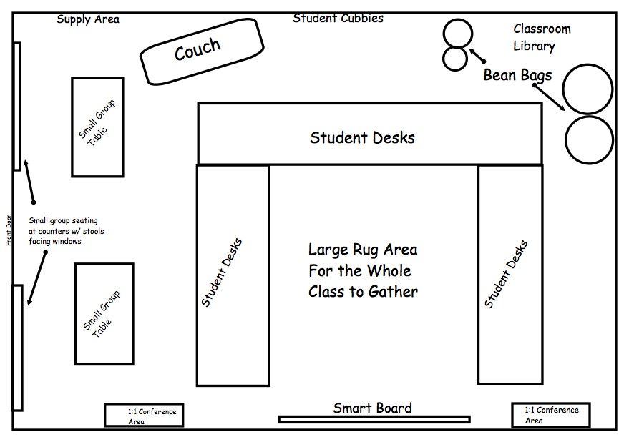

Image from: http://www.teachertriathlete.com/2013_08_01_archive.html

Sample 2

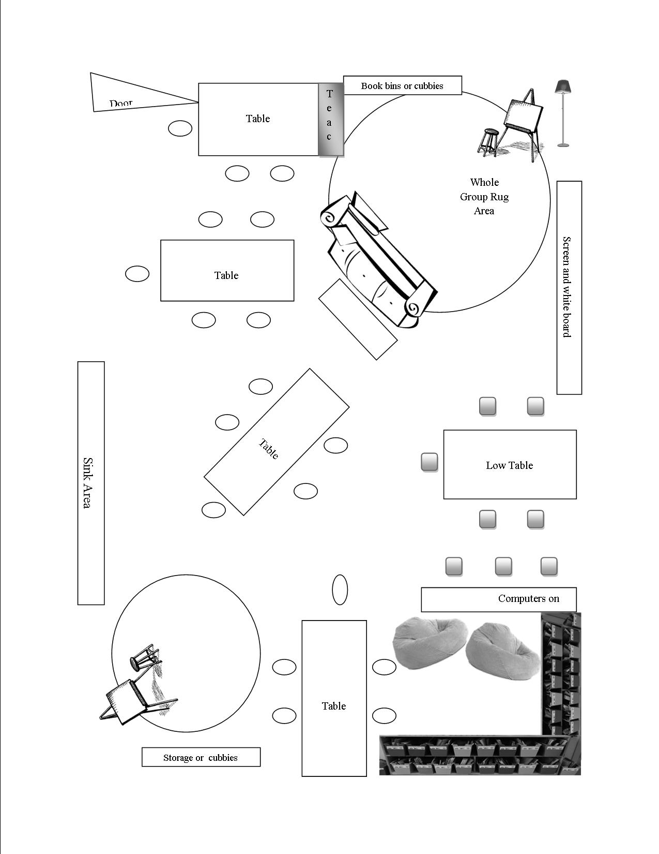

Sample 3

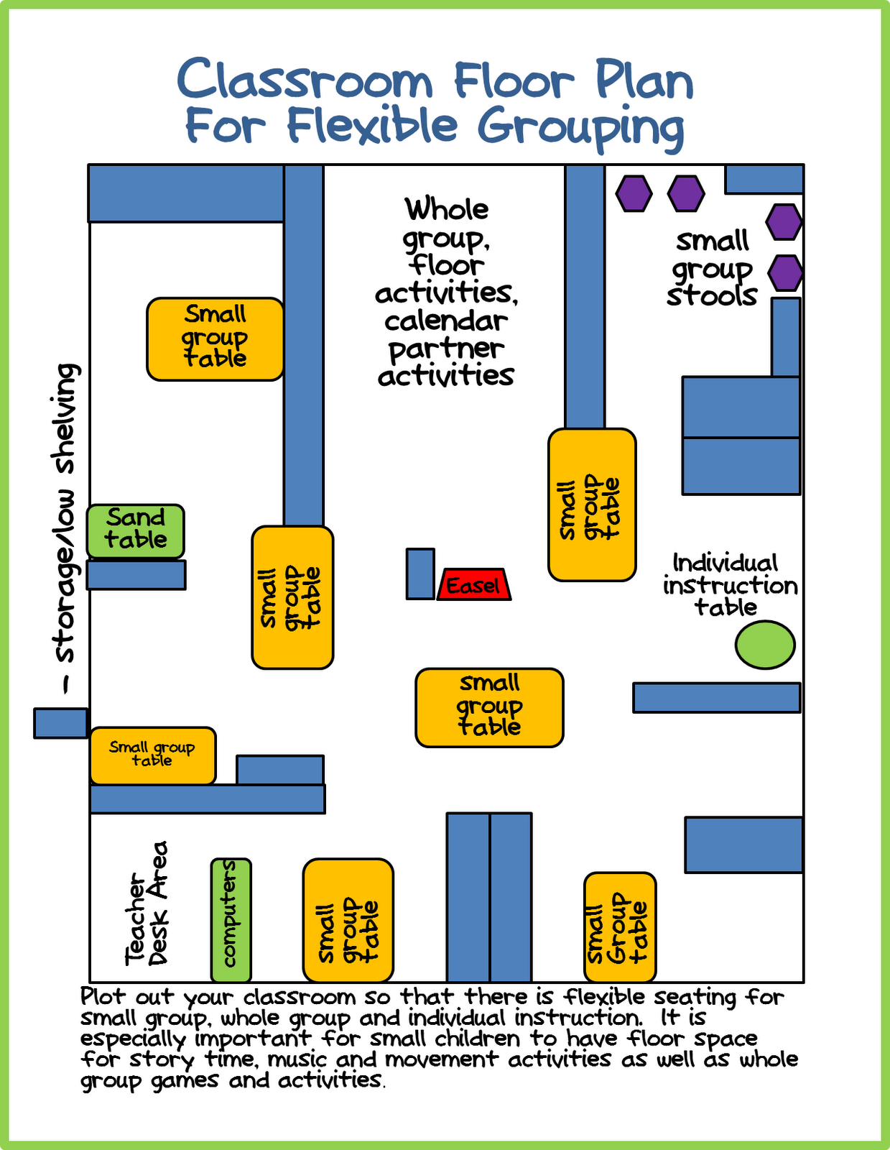

Image from: http://www.differentiatedkindergarten.com/2012/06/making-most-of-my-small-space.html

Leveled Book Rooms
A crucial component of the balanced literacy model is having a leveled library (book room) that houses multiple copies of texts to support small-group intervention and differentiated instruction to meet the needs of diverse learners.

The following information on bookrooms comes from http://www.hmhco.com/shop/education-curriculum/reading/guided-reading/leveled-readers-and-bookrooms/why-leveled-readers/bookrooms

How Do Bookrooms Impact Student Learning?
By using leveled texts precisely matched to their instructional reading level, students are able to move along the reading continuum applying effective reading skills and strategies with progressively more challenging texts. Not only will students gain confidence, they will also master skills in reading, thinking, responding, and writing.

- Your bookroom should have approximately 50% fiction and 50% nonfiction titles.

- Make sure that a wide variety of genres are represented, including chapter books, graphic readers and novels, authentic literature, folktales, poetry, historical fiction, contemporary fiction, fantasy, informational texts, classics, etc.

- Ensure your bookroom collection supports the Common Core State Standards.

- Select leveled reader series for their quality and reader appeal, both in interest and reading level.

- Serve your full student population with books that reflect cultural and linguistic diversity.

- No matter which leveling system you use make certain that you have a sufficient number of books at each level.

- To accommodate students who are reading significantly above or below grade level, take care to choose titles that were written specifically for older children reading well below grade level and for younger children reading well above grade level. This will ensure that students are reading books that are age and interest appropriate.

